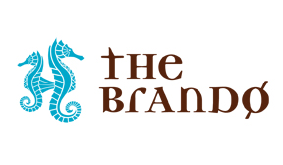
For Immediate Release
January 31, 2019

The Brando is a Finalist for the Tourism for Tomorrow Climate Action Award

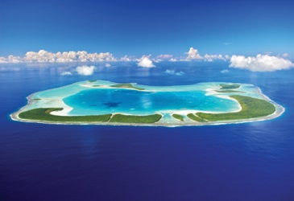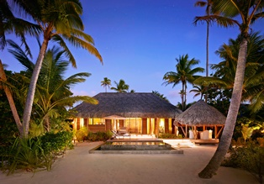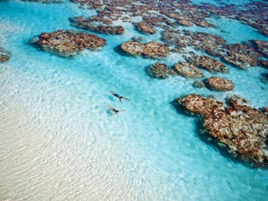

Tetiaroa, French Polynesia – The Brando is pleased to announce that it is a finalist for the 2019 Tourism for Tomorrow Climate Action Award.

Now in their 15th year, the annual Tourism for Tomorrow Awards are presented by the World Travel and Tourism Council (WTTC) and are the world’s top accolade in sustainable tourism, respected by industry leaders, governments and international media alike.

The awards are aimed at recognizing best practice in sustainable tourism within the industry globally, based upon the principles of environmentally friendly operations; support for the protection of cultural and natural heritage; and direct benefits to the social and economic well-being of local people in travel destinations around the world.

There are 15 Tourism for Tomorrow Awards finalists across the five award categories including Climate Action, Investing in People, Destination Stewardship, Social Impact and Changemakers. The Brando is one of only three finalists in the category of Climate Action, which honors organizations undertaking significant and measurable work to reduce the scale and impact of climate change.

Highlights of The Brando’s sustainable tourism efforts include:
- Pioneering innovative new sustainable technologies to mitigate carbon emissions and promote renewable energy, enabling an experience for guests/residents focused on becoming self-sustaining, serving as a model for sustainable tourism globally.
- Co-founding and financially supporting and housing the non-profit Tetiaroa Society, which leads scientific research, protects ancient Tahitian archeological sites, and supports marine and terrestrial conservation, guided by a conservation and sustainable use plan.
- Operating the world’s most innovative air conditioning system, Sea Water Air Conditioning (SWAC). Its development and use were pioneered by Pacific Beachcomber, The Brando’s owner. SWAC reduces energy consumption for air conditioning by nearly 80 percent, without any harmful hydrofluorocarbons.
- Achieving LEED Platinum certification, the first in French Polynesia, and developing strong environmental management systems, including for energy, water, waste management.
- Utilizing solar panels that line the resort’s airstrip, providing up to 70 percent of the resort’s energy with solar heating, providing all hot water for guests and resident staff.
- Presenting educational programs for guests at The Brando comprising lectures and demonstrations of the resort’s environmental efforts; Polynesian culture, history, and lifestyle; and activities led by naturalists to increase understanding and appreciation for the natural and cultural heritage of Tetiaroa.

Following a rigorous three-phase judging process, which includes an onsite evaluation, winners of the 2019 Tourism for Tomorrow Awards will be announced during an awards ceremony at the 19th WTTC Global Summit in Seville, Spain from April 2-4, 2019.

In addition to being selected as a Tourism for Tomorrow finalist, The Brando has also earned other noteworthy recognitions for its environmental efforts, including Virtuoso’s 2015 Best of the Best Sustainable Tourism Leadership Award—Hotels; a Gold Magellan Award for Hospitality Overall: Eco-Friendly “Green” Resort/Hotel from Travel Weekly; and Best Eco-Tourism Property from Luxury Travel Magazine.

To learn more about WTTC and the Tourism for Tomorrow awards, visit: https://www.wttc.org/tourism-for-tomorrow-awards/about-the-awards.

For more information or reservations for The Brando, visit www.thebrando.com or contact your local travel agent or tour operator.

About The Brando
The Brando is an exquisite luxury resort on French Polynesia’s breathtakingly beautiful private atoll of Tetiaroa—an atoll composed of a dozen small islands surrounding a sparkling lagoon 30 miles north of Tahiti. The Brando was inspired by Marlon Brando’s original vision to create a venture of sustainable development that resonates with visitors and fosters opportunities to get to know both the place and people of French Polynesia. The resort is LEED platinum certified, making it the first and only project in French Polynesia to earn LEED certification. With access by Air Tetiaroa, the resort is a pioneering model of sustainable technology with sea water air-conditioning and renewable energies and offers carefree luxury in the midst of pristine nature. The all-inclusive resort features 35 deluxe villas each with its own private beach area and plunge pool, restaurants showcasing Polynesian and French cuisine, a luxurious Polynesian spa, a lagoon-view bar, beach bar, pool, organic garden, library, pearl shop, boutique, water sports, and an Ecostation.

About The World Travel & Tourism Council
The World Travel & Tourism Council (WTTC) is the body which represents the Travel & Tourism private sector globally. Our Members include over 170 CEOs, Chairmans and Presidents of the world’s leading Travel & Tourism companies from all geographies covering all industries. WTTC works to raise awareness of Travel & Tourism as one of the world's largest economic sectors, supporting one in 10 jobs (313 million) worldwide and generating 10.4% of world GDP. WTTC conducts research on the Economic Impact of Travel & Tourism in 185 countries for over 25 years. In 2017, the Travel & Tourism industry experienced 4.6% growth, compared to the global economy (3%). One in five new jobs were created by the industry and is why WTTC is the best partner for governments to create jobs. Our priorities are: Security & Travel Facilitation, Crisis Preparedness, Management & Recovery, and Sustainable Growth. Read more at: https://www.wttc.org.

###
Media Contact:
Vanessa Bloy |The Brando |425-440-6255| Vanessa.bloy@thebrando.com

