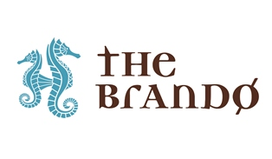

FOR IMMEDIATE RELEASE:

The Brando Honored as “Best Resort in the World”
in Condé Nast Traveler’s 2016 Readers’ Choice Awards

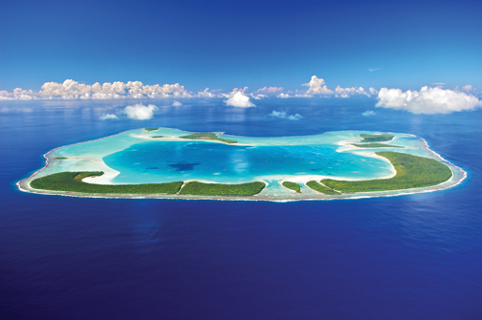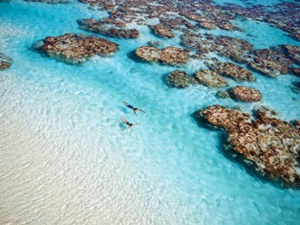

October 18, 2016 – Condé Nast Traveler today announced the results of its 29th annual Readers’ Choice Awards with The Brando receiving top honors as the “Best Resort in the World” with the highest overall score of 99.80. This recognition, the most recent in a series of accolades for The Brando, also marks the private island resort’s debut on the esteemed awards list which celebrates the world’s best hotels, resorts, cities, islands, airlines, and cruise lines.

Mr. Richard Bailey, chairman & CEO of Pacific Beachcomber (which built and operates The Brando), said, “We are thrilled and proud for The Brando team to receive this esteemed ranking as the best resort in the world. This is a significant landmark achievement for a resort that opened just two years ago and we are truly honored.”

The Condé Nast Traveler Readers’ Choice Awards are the longest-running and most prestigious recognition of excellence in the travel industry and are commonly known as “the best of the best of travel.” Under Editor in Chief Pilar Guzmán, the Readers’ Choice Awards have become more selective and specific to the passions that inspire today’s travelers.

Over 300,000 dedicated readers – nearly twice as many as last year – cast votes for 7,394 hotels, 606 cities, 500 cruise ships, and 236 islands, resulting in the 1,402 best travel experiences in the world.

“We always knew our island resort was special and we are thrilled our guests and the magazine’s readers agree,” said Philippe Brovelli, VP of operations for The Brando. “We look forward to welcoming new and returning guests to this uniquely pristine island getaway in the near future.”

Silvio Bion, general manager of The Brando, adds, “This recognition is a true testament to the inspiring and hardworking staff that works tirelessly to provide each guest with one of the most luxurious, authentic and enriching travel experiences available anywhere in the world.”

The Readers’ Choice Awards are announced in the November issue of Condé Nast Traveler, on newsstands nationwide on October 25, 2016. The full list is published exclusively online, at www.CNTraveler.com/rca.

The Brando was previously recognized by Condé Nast Traveler’s editors and contributors on the 2015 Hot List, the definitive guide to the best new hotels and resorts in the world.

For more information or reservations for The Brando, visit www.thebrando.com or contact your local travel agent or tour operator.

# # #

About The Brando
The Brando is an exquisite luxury resort on French Polynesia’s breathtakingly beautiful private atoll of Tetiaroa—an atoll composed of a dozen small islands surrounding a sparkling lagoon 30 miles north of Tahiti. The Brando was inspired by Marlon Brando’s original vision to create a venture of sustainable development that resonates with visitors and fosters opportunities to get to know both the place and people of French Polynesia. With access by Air Tetiaroa, the resort is a pioneering model of sustainable technology with sea water air-conditioning and renewable energies and offers carefree luxury in the midst of pristine nature. The all-inclusive resort features 35 deluxe villas each with its own private beach area and plunge pool, restaurants showcasing Polynesian and French cuisine, a luxurious Polynesian spa, a lagoon-view bar, beach bar, pool, organic garden, library, pearl shop, boutique, water sports, and an Ecostation. The Brando was recently awarded LEED Platinum certification and was the first in French Polynesia to earn this prestigious designation for its conservation and sustainability efforts. The Brando is a founding member of National Geographic Unique Lodges of the World, a collection of boutique hotels in extraordinary places around the world with a demonstrated commitment to sustainability, authenticity and excellence. The Brando is also a Virtuoso Preferred Resort.

For further media information, please contact Victoria King Public Relations:
Telephone: (310) 207-5175 and email: info@vkpr.com

About Condé Nast Traveler
As the most discerning, up-to-the-minute voice in all things travel, Condé Nast Traveler is the global citizen’s bible and muse, offering both inspiration and vital intel. Condé Nast Traveler is the most trusted and celebrated name in travel with 6 National Magazine Award wins and 26 nominations in its 28-year history. Advertising Age named Pilar Guzmán Editor of the Year in 2014 and CNTraveler.com attained 4 Webby Awards since 2015. www.cntraveler.com

Press Contact:
Victor De Vita – 212 286 6449 victor_devita@condenast.com

