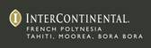

THE SECRET GARDEN OF LOVE OPENS AT
THE INTERCONTINENTAL BORA BORA RESORT & THALASSO SPA
“FIND YOUR SWEETHEART, GET A LOCK & SEAL YOUR LOVE”

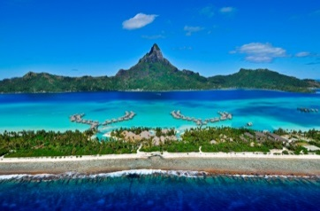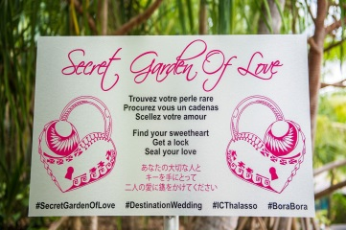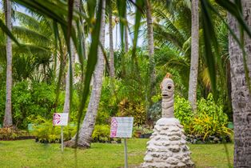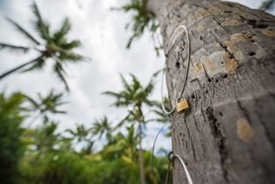

BORA BORA, FRENCH POLYNESIA – January 27, 2016 – Reminiscent of Pont des Arts in Paris, Rome’s Ponte Milvio Bridge, and the padlock trees of love in Moscow, the InterContinental Bora Bora Resort & Thalasso Spa has created a romantic secret garden of love in the resort’s botanical garden where sweethearts can symbolize their eternal devotion by sealing their love with a lock in Bora Bora in Polynesian style.

Honeymooners, those celebrating a wedding anniversary, or amours, can leave their mark of love. In the quiet and intimate garden, guests can select between four Polynesian symbols—the turtle, the sun, the sea shell, and the lizard, which each correspond to a specific palm tree.

- The turtle is one of the most important and popular elements in Polynesian culture. It symbolizes many meanings including long life, wellness, fertility, union, family and harmony.

- The sun in Polynesian culture often stands for riches, brilliance, grandness and leadership. Similar to other cultures, the sun’s periodic rising is regarded as eternity and connected to rebirth.

- Seashells often symbolize shields, protection and intimacy in Polynesian culture. The designs have many variations and styles. Bivalve shells symbolize couples and marriage.

- Lizards are important part of Polynesian beliefs and regarded as forms of gods, who can speak to gods, watch the hidden world, and are regarded as ancestors of Polynesian people.

Lovers can then attach their lock to the palm tree with their chosen symbol and throw away the keys in the garden’s Tiki, which symbolizes the protection of love forever. Guests are encouraged to bring their own customized lock. Locks are also available for purchase in the resort’s boutique.

The InterContinental Bora Bora Resort & Thalasso Spa is located on a virgin beach on Motu Piti Aau with breathtaking views of Bora Bora’s majestic Mount Otemanu. Known for its exemplary service to its guests, the resort features a number of unique attributes, including: 80 luxurious overwater villas each with a split-level terrace and sundeck for easy access to the turquoise waters of the lagoon; two of the finest culinary experiences in French Polynesia at its restaurants Reef and Corail; and the first overwater wedding chapel with glass bottom floor in French Polynesia.
The resort’s Deep Ocean Spa by Algotherm is the very first spa to utilize the benefits of deep-sea water and minerals extracted from the Pacific Ocean in its signature spa treatments. InterContinental Bora Bora Resort & Thalasso Spa was also the first resort in the world to produces its own air-conditioning from water extracted from the ocean.
Recently, Deep Ocean Spa at the InterContinental Bora Bora Resort & Thalasso Spa was awarded “French Polynesia’s Best Hotel Spa” in the inaugural World Spa Awards. InterContinental Bora Bora Resort & Thalasso Spa was also voted “Australasia’s Leading Spa Resort” and “French Polynesia’s Leading Spa Resort” at the 2015 World Travel Awards. The InterContinental Bora Bora Resort & Thalasso Spa was also recognized as one of the “Top 25 Resorts in Australia and the South Pacific” in Condé Nast Traveler’s 2015 Readers’ Choice Awards and was honored by readers in the Travel + Leisure 2015 World’s Best Awards as one of the “World’s Best Resorts in Australia, New Zealand, and the South Pacific.”

For information and rates for the InterContinental Bora Bora Resort & Thalasso Spa, call 1-888 IC HOTELS (1-888-424-6835) or visit www.thalasso.intercontinental.com.

###

About InterContinental Resorts French Polynesia
Owned and operated by Richard H. Bailey and his company, Pacific Beachcomber S.C., there are four InterContinental Resorts in French Polynesia: InterContinental Bora Bora Resort & Thalasso Spa, InterContinental Bora Bora Le Moana Resort, InterContinental Tahiti Resort & Spa, and InterContinental Moorea Resort & Spa. Each of the resorts has completed multimillion dollar enhancements over the course of the last five years and each partakes in IHG's Green Engage program.

Media Contact:
Vanessa Bloy
InterContinental Resorts French Polynesia
425-440-6255
vbloy@pgcruises.com

